Admin Community Profile

Admin Community Profile

Users  - Primary  - Community manager  - Secondary | Phase 1
Intended Outcome
- Organizers create their community profile as they want to introduce their communities to outsiders and prospective members.
Links
- …
- …
- …
- …
- …

Introduction
Admin Community Profile empowers community organizers to craft, manage, and showcase their community’s identity within Kolavo. With this epic, organizers can freely create and update their community profile—including essential details like the community name, description, logo, location, and other key identifiers—to introduce their organization to outsiders and prospective members.

By enabling organizers to design a profile that truly represents their community’s spirit, vision, and unique value, Kolavo helps every organization put its best face forward. The result: communities stand out, attract the right audiences, and make a welcoming first impression for anyone exploring or considering joining.

Definition
Community fullname: Name of community that organizers officially created which usually has more than two words and describes the community itself.
Community abbreviation: Shorter way to pronounce community fullname by abbreviating it.

Product Requirement
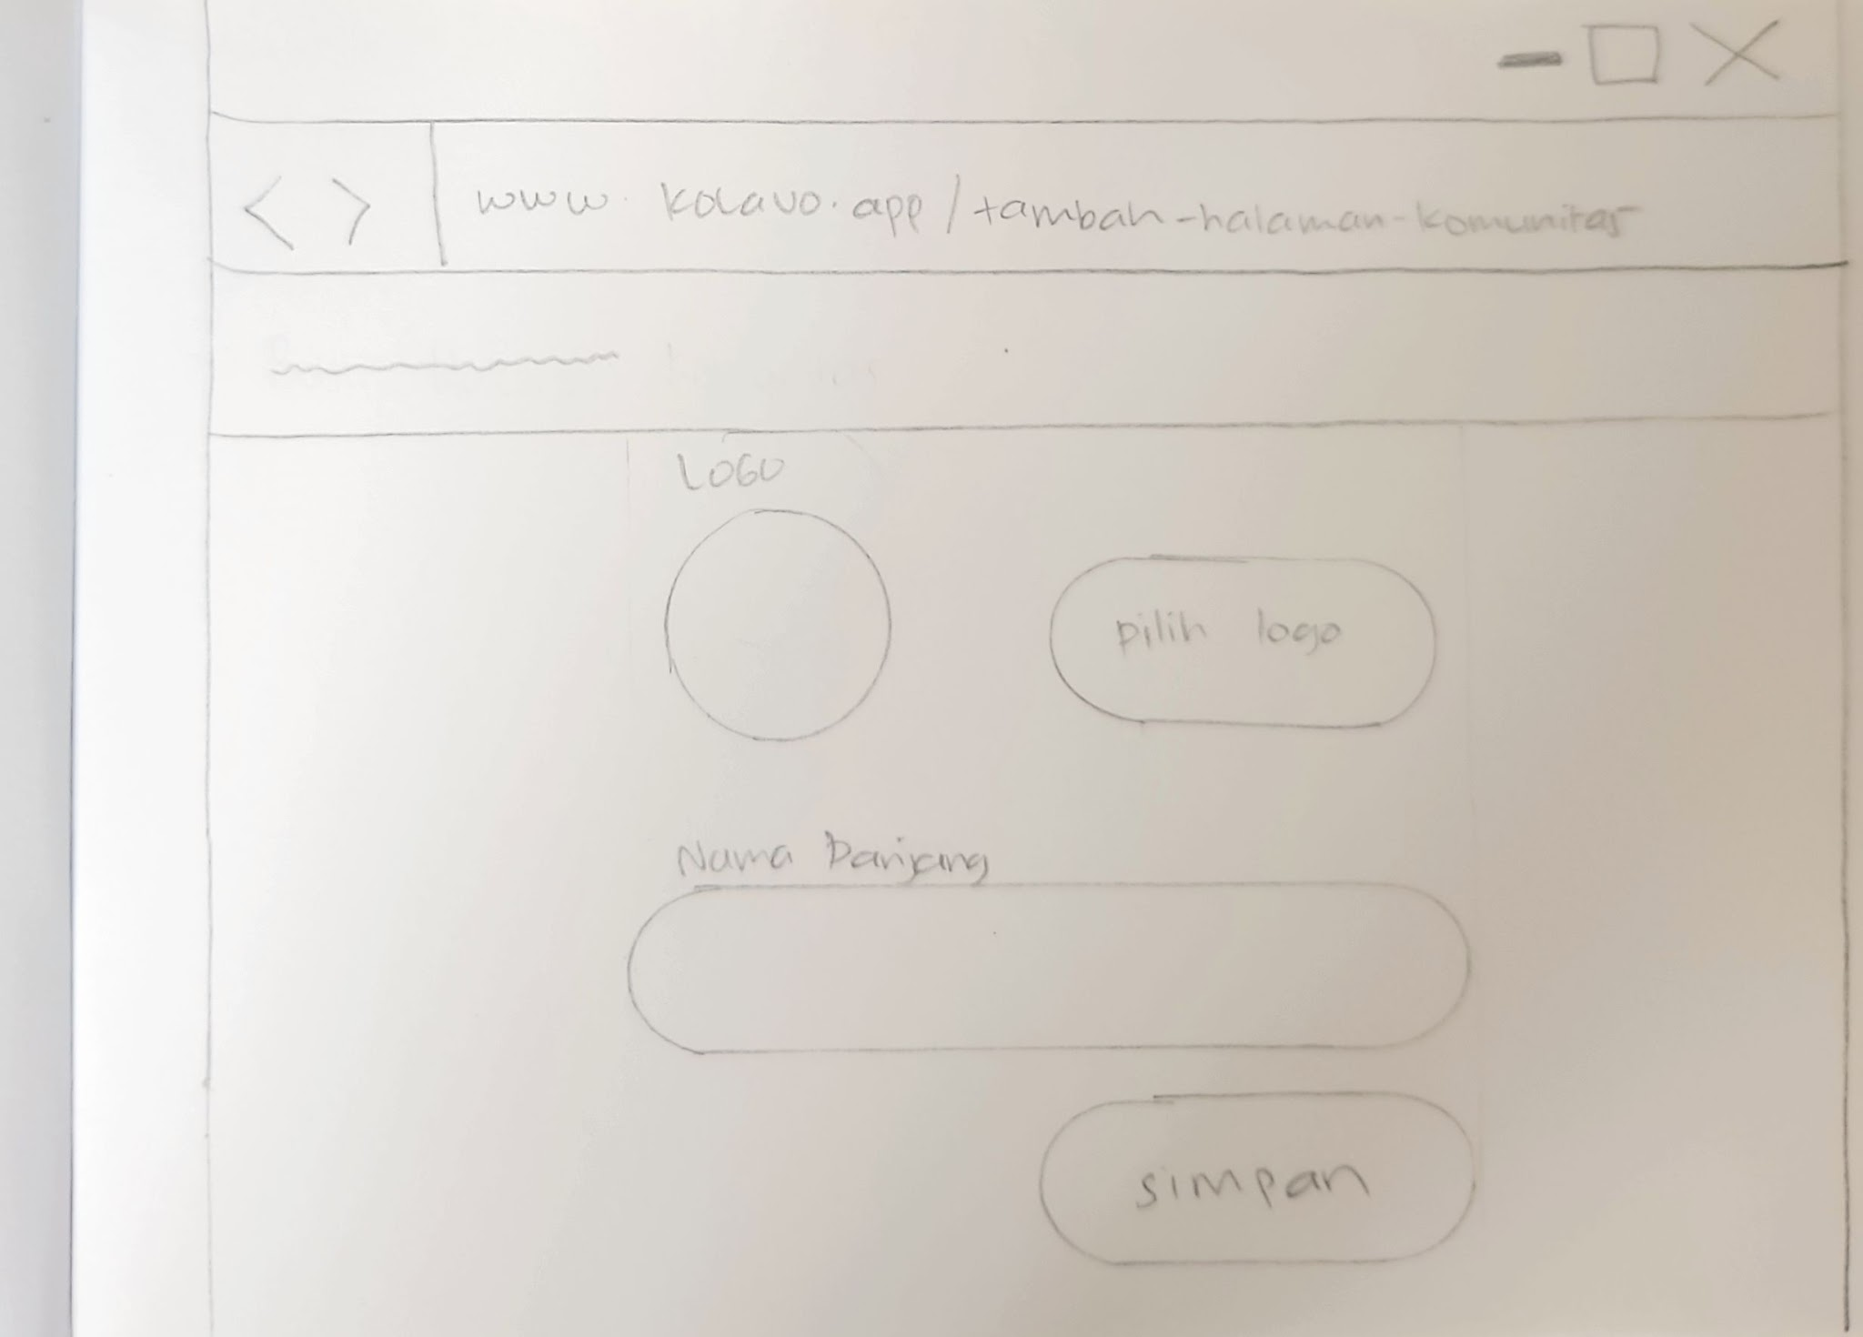
Create community page form

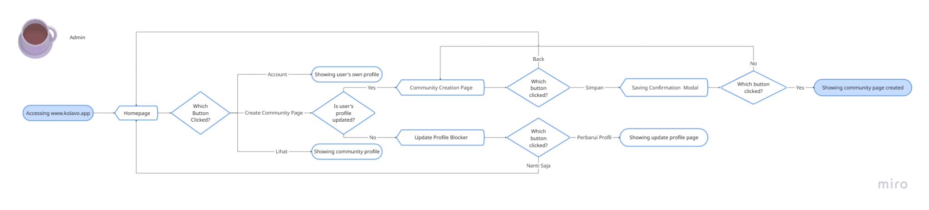
Create community page flow

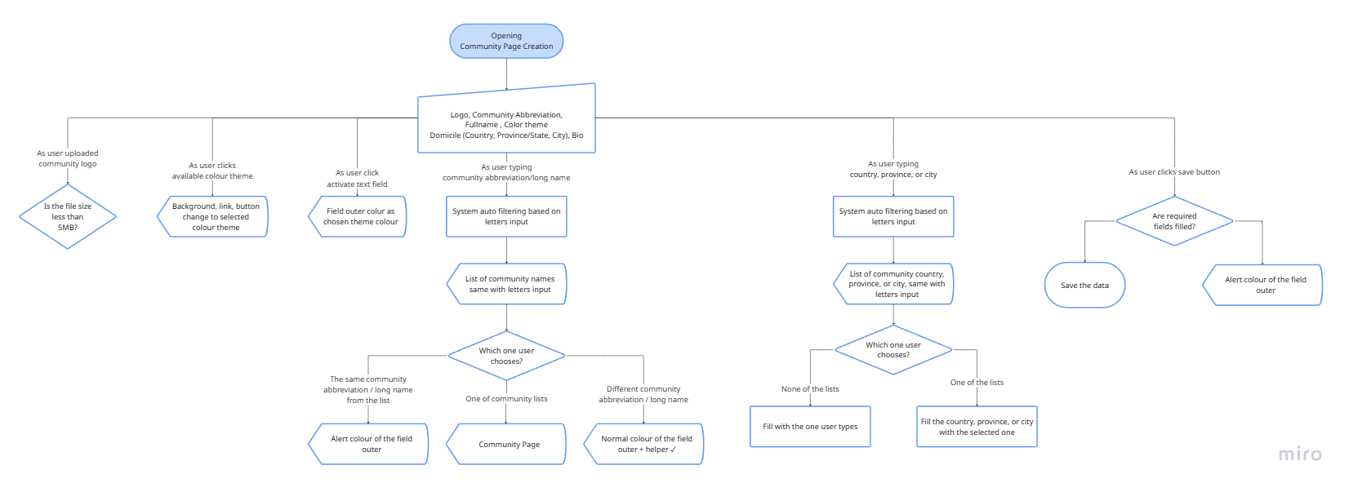
Interaction Flow of Create Community Page Form

No. | User Stories | Scope | Acceptance Criteria
1 | As a tech dev and uiux designer, I want to understand the flow of creating community pages, so I can design and develop following the flow. | Creating community page flow | - Users login  - Users update profile (if not done yet)  - Users create community page start from filling in community profile  - Users who create community profile automatically becomes Community Page Admin
2 | As a user who skipped onboarding and did not update my profile, I want to be reminded why I couldn’t create a community page, so I can follow the right steps. | Blocker modal | - Modal shows only to users who want to create community page by clicking create community page but did not update their profile  - The modal explain friendly why and encourage users to update by also giving a button to edit profile page  - The modal also give another option to skip updating profile which will close the modal and stays in current page
3 | As community managers I want to create my community page, so that my community can be represented publicly in Kolavo. | Community Page Creation Form | - Only logged in users can access community page creation form  - Not logged in users are redirected to login before accessing the form  - Form allows users to fill in information including:  - Logo  - Abbreviation  - Fullname  - Color theme  - Domicile (Country, Province/State, City)  - Bio  - It allows users to save or cancel  - If users click save, community page is created and redirect to created community page
4 | As community managers, I don’t want the same community created, so members won’t be confused where to join. | Community Page Creation Warning | - Show list of match registered community as users typing community long name  - The list of community is clickable and redirect to related community page  - If the name is the same and the user keeps using it, give warning about community page creation.
5 | As Kolavo product team, I don’t want to input all cities around the world, because we don’t have the resources. | Users Domicile Data Input | - Data input by users is saved and able to reused  - List of domicile is shown as users typing  - Users can choose domicile from shown list
6 | As community managers, I would like to update my community profile, because we need to adapt to changes. | Community Profile Edit | - Only community managers who created community page can edit it  - Button to edit page is shown in community profile  - Logged in is required to edit community page  - All data is saved in front end first
7 | As community managers, I would like to easily understand the states about the community page I created | Community Page States | - Community listed in homepage only when it is published, otherwise it is draft and not shown in homepage.  - Community page creators can publish its page after setting up membership identifications.  - Community page creators can see two distinct states of their community pages.
8 | As community page creators, I want to easily know the status of my community page, so I feel the urge to take action. | Community page status sign | - Sign only shown if the community page status is Drafted, otherwise not shown.  - Sign located above the community profile to be the first to see.

Design Requirement

Blocker Modal
Design Intent | Educate users that updating profile is required and guiding them to access the update profile page
Content / Copy | - Illustration: not known illustration  - Modal title: Kamu belum dikenali  - Body: Lengkapi profil mu agar bisa dikenali untuk membuat dan bergabung ke komunitas.  - Update profile button: Perbarui Profil  - Skip button: Nanti saja
Visual Requirement
Interaction Behavior | - Opens update profile page when Update profile button is clicked  - Close the modal when skip button is clicked
Acceptance Criteria

Admin Community Creation Page

Breadcrumbs
Design Intent | Ease users access homepage containing list of communities from community page
Content / Copy | - Mobile: < Buat Halaman Komunitas  - PC: doesn’t need one
Visual Requirement
Interaction Behavior | - When click </:  - If there was no changes, returns to previous page  - If there was changes, data is saved in front end and returns to previous page
Acceptance Criteria

Community Page Creation Form Layout
Design Intent | The header and form element should feel like one cohesive identity block, similar to a profile layout rather than a document.
Content / Copy
Visual Requirement | - By default use Kolavo brand color until the theme color is chosen.
Interaction Behavior
Acceptance Criteria

Community Page Creation Form Header
Design Intent | To highlight the function of the Community Page Creation Form
Content / Copy | Perkenalkan Komunitasmu
Visual Requirement
Interaction Behavior
Acceptance Criteria

Logo File Upload
Design Intent | To acquaint users the place of uploading community logo
Content / Copy
Visual Requirement
Interaction Behavior | - Opens browse picture when upload button clicked  - Show chosen picture in logo preview  - Remove chosen picture in logo preview when remove button clicked  - Use first initial community long name when saving the info but no logo uploaded
Acceptance Criteria

Community Color Theme
Design Intent | To acquaint users the place of changing community color theme
Content / Copy | Label: Warna Tema
Visual Requirement
Interaction Behavior | - Give outer with same color chosen  - Change the color on elements like field outer, button and link.  - The changes affect to every mentioned element in all pages related to the saved community setup
Acceptance Criteria

Community Abbreviation
Design Intent | To acquaint users the place of inputting community abbreviation
Content / Copy | - Label: Nama Singkatan  - Field: Nama Singkatan  - Helper text: Nama singkatan komunitas harus unik dan belum pernah digunakan.  - Helper icon: ✓
Visual Requirement
Interaction Behavior | - When activated border change to thin transparent chosen theme color  - When users typing, show list of clickable registered communities whose name are similar  - Open clicked community profile, when one of those names is clicked  - Helper icon changes to community theme color when community abbreviation achieves the rules, otherwise disabled color.
Acceptance Criteria

Community Fullname
Design Intent | To acquaint users the place of inputting community fullname
Content / Copy | - Label: Nama Lengkap  - Field: Nama Lengkap  - Helper text: Nama lengkap komunitas harus unik dan belum pernah digunakan.  - Helper icon: ✓
Visual Requirement
Interaction Behavior | - When activated border change to thin transparent chosen theme color  - When users typing, show list of clickable registered communities whose name are similar  - Open clicked community profile, when one of those names is clicked  - Helper icon changes to community theme color when community fullname achieves the rules, otherwise disabled color.
Acceptance Criteria

Community Country Location
Design Intent | To acquaint users the place of inputting community country location
Content / Copy | - Label: Negara  - Field Placeholder: Nama Negara
Visual Requirement
Interaction Behavior | - When users type letters, the system shows a list of recommendations based on the letters typed and availability in the database.  - If no country name is the same, the system saves it with capital letters of each word.
Acceptance Criteria

Province Location
Design Intent | To acquaint users the place of inputting community province location
Content / Copy | - Label: Provinsi  - Field Placeholder: Nama Provinsi
Visual Requirement
Interaction Behavior | - When users type letters, the system shows a list of recommendations based on the letters typed and availability in the database.  - If no country name is the same, the system saves it with capital letters of each word.
Acceptance Criteria

Community City Location
Design Intent | To acquaint users the place of inputting community city location
Content / Copy | - Label: Kota / Kabupaten  - Field: Nama Kota / Kabupaten
Visual Requirement
Interaction Behavior | - When users type letters, the system shows a list of recommendations based on the letters typed and availability in the database.  - If no country name is the same, the system saves it with capital letters of each word.
Acceptance Criteria

Bio
Design Intent | To acquaint users the place of inputting text they want to show
Content / Copy | - Label: Bio  - Field placeholder: Apa yang pengunjung perlu tau tentang komunitasmu?  - Alert: 0/150
Visual Requirement
Interaction Behavior | - Alert:  - The numerator showing number of character as users typing  - Stop inputting when character reach 150
Acceptance Criteria

Save Button
Design Intent | To allow user saving the information filled in the form
Content / Copy | Simpan Profil
Visual Requirement
Interaction Behavior | - When clicked data is saved and shows confirmation modal
Acceptance Criteria

Confirmation Modal
Design Intent | To encourage users inputting correct data
Content / Copy | - Illustration: questioning illustration  - Modal title: Simpan Profil Komunitas?  - Body: Tenang saja, kamu masih bisa mengubah logo, warna tema, dan deskripsi nanti di menu Pengaturan.  - Button yes: Ya, Simpan Komunitas  - Button back: Cek Kembali Data
Visual Requirement
Interaction Behavior | - Opens community page when Lihat Halaman button is clicked
Acceptance Criteria

Admin Community Page

Community Page Status Sign
Design Intent | Ease community managers to understand the state of their community pages
Content / Copy | - Draft: Belum diterbitkan  - Published: no sign needed
Visual Requirement | - It should be visible and makes the users aware of the community page state  - Appearing not as update but rather a state
Interaction Behavior
Acceptance Criteria
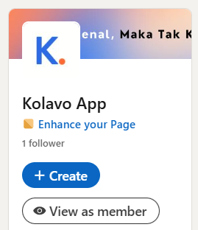
State Reference from LinkedIn

Community Profile
Design Intent | The logo and profile information should feel like one cohesive identity block, similar to a profile layout rather than a document header.
Content / Copy | Includes:  - community logo  - Fullname: [community fullname]  - Domicile: [country flag] [city], [province] if filled  - Bio: [bio] if filled  - Edit profile button: Ubah Profil Komunitas
Visual Requirement
Interaction Behavior | - When logo is not uploaded, use first initial letter looking matching with community theme color  - Clicking edit profile button directs to edit community profile page
Acceptance Criteria

Engineering Requirement

Questions

